Response Letter

Ref: adfm.202412071
Title: Evaporation-Induced Composition Evolution in Metal Additive Manufacturing

August 2, 2024

Dear Editor and Reviewers:

Thank you very much for the constructive comments on our manuscript. We have tried our best to address the comments and have revised the manuscript accordingly. Please see our itemized list of detailed response and revisions. The revised manuscript is also included in full with all changes highlighted in red.

We appreciate your further consideration of the revised manuscript to be published.

Sincerely,

Wentao YAN

PhD, Assistant Professor
Department of Mechanical Engineering
National University of Singapore
Tel: +65 6601 7230
E-mail: mpeyanw@nus.edu.sg
Website: https://blog.nus.edu.sg/yanwt/

Itemized list of response to the comments

(The comments are in blue and our responses in black; revisions in the manuscript are in red)

Reviewer #1:
The submitted manuscript presents the evaporation-induced composition evolution in laser welding and laser remelting rather than metal additive manufacturing (MAM) using multiphysics/high-fidelity models, ICP-MS, and EPMA experimental data. Indeed, it is a topical and important area to study the control of elemental evaporation in such a process as this has a direct impact on the component properties. However, the authors have not attempted to model the actual MAM process. There are several aspects of the manuscript remain unclear due to insufficient experimental evidence to support the conclusions of this research topic. Here is a list of remarks that the authors to be considered, including:

Response:
Thank you very much for your recognition and constructive suggestions.

Introduction:
- Explain why AA7075 should be selected for this model as this is an uncommon powder feedstock for LPBF and the MAM industry. I think the authors should tone down the claim that the model can be generally applied to various materials (as you have not provided evidence of 2 – 3 alloys that are substantially different to AA7075). In terms of generally applicable to other MAM techniques, you have also not provided sufficient evidence to support that such a model can be applied to electron beam wire/powder processes or directed energy deposition as each process undergoes different thermal conditions.

Response:
Thank you for your suggestion. In the past 15 years, aluminum alloys have gained popularity in metal additive manufacturing, especially for aerospace applications, as noted in references [24, 31, 32]. We have added an explanation about it in the manuscript as attached below.

To demonstrate the versatility of our model across various materials, we conducted multi-layer simulations of high-entropy alloys to predict concentration distributions in components fabricated via laser powder bed fusion (L-PBF) under varying laser powers as described in the supporting information. Our results, encompassing both simulated element concentrations and energy-dispersive spectroscopy (EDS) measurements, indicate that the concentration evolution model accurately simulates local concentrations in the molten pool and predicts concentrations in the fabricated parts. Additional explanations regarding the application of our model to the high-entropy alloy system are included in the manuscript as attached below.

The main thermal condition difference between different metal additive manufacturing techniques are the heat source and ambient environment. Our multiphysics thermal-fluid flow model is applied to electron beam powder process and directed energy deposition [R1-R3] by adjusting the heat source and raw material feeding process and validated against experiments. The model is validated against in-situ X-ray imaging results of keyhole dynamics, bubble flow, and molten pool flow under different ambient pressure [47, R4]. These studies have demonstrated that this model is able to provide accurate temperature distribution and liquid flow under different thermal conditions by adjusting different heat source model and evaporation condition. Moreover, the element evaporation and concentration evolution processes are mainly determined by the local element temperature and molten pool flow. With our previous evaporation model [47], we can calculate the local element evaporation rate of different elements in the alloy at different positions. Due to the limited experimental conditions and material property data, we have not conducted more experiments and simulations. We have addressed these limitations of the current study as attached below.

In line 35-37
As the second most used alloys after steels, aluminum alloys play an important role in the aerospace industry and becomes popular in MAM in the last 15 years [24, 31, 32].

In line 43-44
Due to the limited experimental conditions and material property data, this study mainly focuses on laser-fusion additive manufacturing and two alloys.

In Supplementary Information
It should be clarified that the proposed element concentration prediction model is not limited to this particular alloy system. We have applied this element evolution model to predict Mn concentration of L-PBF fabricated FeMnCoCr from both calculated mass loss rate and remelting simulation. As shown in Figure S6a, the laser scans on one powder bed layer after another in the L-PBF. To validate the current model, two different laser powers (Case 1: 180 W and Case 2: 270 W) with constant laser scanning speed ($0.6 m/s$)are adopted for comparison. To simplify the simulation, only one track is simulated in each layer at the same track position. To smooth the track surface, the scanning direction rotates $180°$ between the adjacent layers in the simulation. The simulation process is similar to our previous study [9], where the powder layer spreading process is simulated with Discrete Element Method (DEM) [10] first and then laser scanning on the powder bed with the current multiphysics thermal-fluid flow model in a layer scanning process. According to the experiments by Bidare et al.[11], the practical powder layer thickness is about two times of set layer thickness ($30 μm$ in the current experiments) due to the powder layer porosity and powder spattering effect. Thus, the first layer thickness in the simulations are $60 μm$, and subsequent layer height is $30 μm$ above the previous layer. With the current FeMnCoCr HEA compositions, the prediction of total mass loss and Mn mass loss at different temperatures are predicted in Figure S6b through the evaporation model. Since the boiling temperature of Mn (2334 K) is much lower than other elements in the FeMnCoCr HEA, the evaporation calculation shows that the mass loss is mainly due to the Mn evaporation and Mn concentration will have the maximum change in L-PBF.

To validate the concentration evolution model, the simulated mass losses are given in Figure S6c, when the molten pool shape is stable. The mass loss curves in Figure S6care linear, which means the mass loss rate are constants during each laser scanning track. The Mn concentration $C_{Mn}$ in the final part can be predicted with the mass loss rate of Mn
$$C_{Mn}=\frac{C_{0}M-{\dot{m}}_{c}t}{M}$$
where $C_{0}$ and $M$ are the initial Mn concentration and mass of the final part. ${\dot{m}}_{c}$ is the Mn mass loss rate calculated from the first laser track simulation (Figure S7a-b) and given in Table S8.

Figure S6
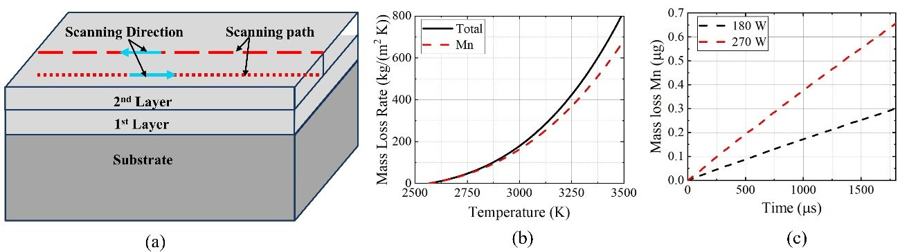

Figure S6 (a) Scheme of L-PBF for HEA. (b) The total and Mn mass loss rate if FeMnCoCr HEA at different surface temperature. (c)Evaporation mass loss of Mn in first track at different laser power.

Figure S7
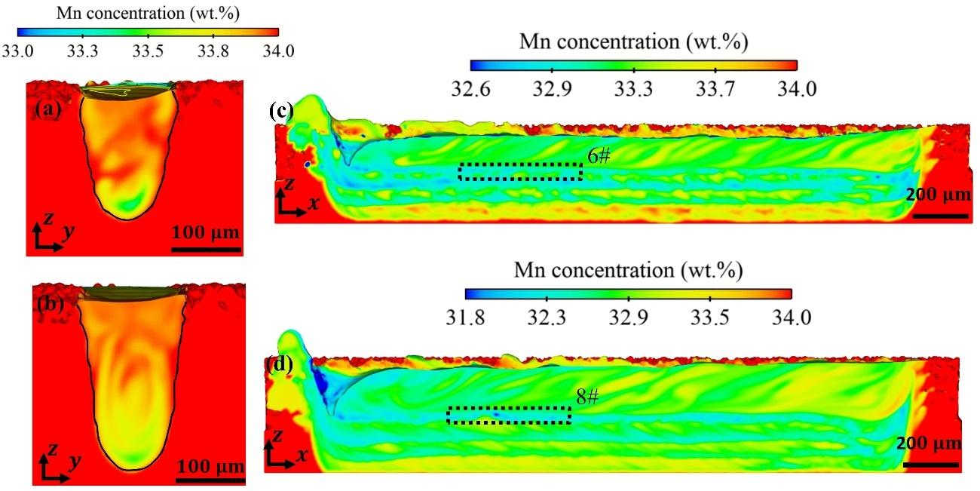
Figure S7: (a-b) The simulated Mn concentration distribution in the first laser scanning under Case 4 and 5. (c-d) The simulated Mn concentration distribution of multi-layer laser scanning under Case 4 and 5. The Mn concentration at the bottom of each track is circled with the black dashed rectangle with the corresponding number.

Table S8
Table S8. Mn mass fraction of L-PBF fabricated FeMnCoCr HEA
 |  | Case 4 | Case 5
Mn mass loss rate (g/s) |  | 167.12 | 364.67
Mn concentration (wt. %) | Exp. | 33.1 | 30.9
Mn concentration (wt. %) | Sim. | 33.0 | 31.7
Reference
[24] Zhu Z, Hu Z, Seet H L, et al. Recent progress on the additive manufacturing of aluminum alloys and aluminum matrix composites: Microstructure, properties, and applications[J]. International Journal of Machine Tools and Manufacture, 2023, 190: 104047.
[31] Martin J H, Yahata B D, Hundley J M, et al. 3D printing of high-strength aluminium alloys[J]. Nature, 2017, 549(7672): 365-369.
[32] Rometsch P A, Zhu Y, Wu X, et al. Review of high-strength aluminium alloys for additive manufacturing by laser powder bed fusion[J]. Materials & Design, 2022, 219: 110779.
[47] Wang L, Zhang Y, Yan W. Evaporation model for keyhole dynamics during additive manufacturing of metal[J]. Physical Review Applied, 2020, 14(6): 064039.
[R1] Yan W, Ge W, Qian Y, et al. Multi-physics modeling of single/multiple-track defect mechanisms in electron beam selective melting[J]. Acta Materialia, 2017, 134: 324-333.
[R2] Yan W, Ge W, Smith J, et al. Multi-scale modeling of electron beam melting of functionally graded materials[J]. Acta Materialia, 2016, 115: 403-412.
[R3] Yang Z, Wang S, Zhu L, et al. Manipulating molten pool dynamics during metal 3D printing by ultrasound[J]. Applied Physics Reviews, 2022, 9(2).
[R4] Wang L, Zhang Y, Chia H Y, et al. Mechanism of keyhole pore formation in metal additive manufacturing[J]. npj Computational Materials, 2022, 8(1): 22.

- I’d recommend the authors to tone down the claim about ‘…the model is applicable to MAM..’ if your work only considers bare plates. Unless you re-run the models with powder, wire, or feedstock to be considered as MAM.

Response:
Thank you for your suggestion. We not only run simulation on bare plate, but also run simulation with powder for high entropy alloy as shown in Figure S6. As for the AA7075 cases, to mitigate the influence of powder particles, bare plates were utilized to enhance the composition distribution patterns. Powder particles in L-PBF affect laser reflection, local laser absorption, and local temperature, thereby influencing local element evaporation. Consequently, the errors induced by powder particles in EPMA and simulation results were minimized. Additionally, multi-layer simulations were performed for the high-entropy alloy to predict concentration in L-PBF fabricated components under various laser powers, and these predictions were validated against experimental results as discussed in Supporting Information. Figure S6 illustrates the predicted element loss and concentration in final parts at different laser powers. Figure S7 also presents simulated element concentrations in final parts, which align with the experimental results listed in Table S8. The simulated Mn concentrations in the L-PBF fabricated component are also validated against EDS results. Due to the limited experimental conditions and material property data, we have not conducted more experiments and simulations. We have addressed these limitations of the current study and added a detailed explanation about L-PBF simulation in the manuscript as attached below.

In line 43-44
Due to the limited experimental conditions and material property data, this study mainly focuses on laser-fusion additive manufacturing and two alloys.

Figure S6

Figure S6 (a) Scheme of L-PBF for HEA. (b) The total and Mn mass loss rate if FeMnCoCr HEA at different surface temperature. (c)Evaporation mass loss of Mn in first track at different laser power.

Figure S7
Figure S7: (a-b) The simulated Mn concentration distribution in the first laser scanning under Case 4 and 5. (c-d) The simulated Mn concentration distribution of multi-layer laser scanning under Case 4 and 5. The Mn concentration at the bottom of each track is circled with the black dashed rectangle with the corresponding number.

Table S8
Table S8. Mn mass fraction of L-PBF fabricated FeMnCoCr HEA
 |  | Case 4 | Case 5
Mn mass loss rate (g/s) |  | 167.12 | 364.67
Mn concentration (wt. %) | Exp. | 33.1 | 30.9
Mn concentration (wt. %) | Sim. | 33.0 | 31.7

- The authors should explain why cracking formation is important as there is no mention of such imperfection until the last paragraph.

Response:
Thanks for your suggestion. Differences in local element concentration and temperature history can lead to non-uniform microstructure evolution, which may result in crack formation and consequently reduce the strength of the as-built parts. We have added an explanation about it in the manuscript as attached below.

In line 9-14
Recent ex-situ studies [14-23] found that the evaporation-induced composition variation will influence phase transformation, changes the grain morphology, and mechanical property under different processing parameters. Combine the local temperature history and element concentration variation, the dendrite/grain growth becomes uncontrollable dendrite, and even forms cracking, which will decrease the strength of the as-built parts [24]. However, there are no effective solutions to control element evaporation and optimize the component composition to improve the quality consistency of components.

Results and discussion
- The differences between the experimental and simulation results can reach up to 18%. I think the authors should not take this value lightly in the discussion and should detail and address the drawbacks of the simulation model.

Response:
Thank you for your suggestion. The analysis of the difference between simulation and experimental results was discussed in the Supporting Information. We have added the discussion about it in the manuscript as attached below.

In line 74-81
Compared to the experiments, the uncertainty of material properties (e.g. viscosity, surface tension, thermal conductivity, specific heat, etc.), real processing parameters (e.g. laser power, diameter, and defocusing), and laser attenuation by the vapor plume are not considered in the simulations due to the lack of related data. Moreover, the oxidization in the bare plate (after polishing) decreases the wettability [31,32] and influences the laser absorption and element evaporation. Considering these factors, the multiphysics thermal-fluid flow simulation results for molten pool flow are reasonable and the molten pool dimensions between the experimental and simulation results, less than 18%, is acceptable.

- Can you further comment on why there is a further reduction of Zn and Mg during remelting? The circulation cells and mixing in these results appear to be less mixed than in the experiential results. Do you have any thoughts on that?

Response:
Thank you for your suggestion. Due to the element evaporation and liquid mixing process, the concentration decreases further. The Zn concentration in the substrate is non-uniform as shown in the EPMA results, while it is uniform in the simulation. Thus, after evaporation and liquid mixing, the simulated concentration is less than that in experiments. This difference is reduced during the remelting process as shown in Figure 1d-e. We have added more comments on element evaporation during the remelting process and explain the reasons of mixing difference between the simulation and experimental results in the manuscript as attached below.

In line 96-106
Moreover, in the remelted track (Figure 1d-e), the concentration at the edge and middle of the tracks decreases further compared to that in the first melt track Figure 1b-c), and the lower limit of Zn concentration decreases from 3.5 wt.% to 3.0 wt.%. due to the further element evaporation and liquid convection. At the same time, the Zn segregation in the upper and bottom regions in both EPMA and simulation results becomes more obscured after remelting, as shown in Figure 1d-e. In the simulation, the Zn concentration in the substrate is assumed to be uniform; however, the EPMA measured Zn is unevenly distributed in the substrate (Figure 1b). Moreover, defects such as micropores and cracks in the substrate affect the molten pool flow. These factors contribute to the more pronounced concentration deviation in the first track, as shown in Figure 1c, compared to that in EPMA results. As remelting times increase, this concentration distribution deviations decrease, as illustrated in Figure 1d-e.

- Although the range of the Zn concentration is similar, the distribution of the Zn concentration within the melt pool appears significantly different. The average and standard deviations of the composition are much higher in the simulation than in the experimental results. Could the authors further explain that? I think box plots should provide a better comparison and benchmark against the nominal composition of feedstock/bare plate (in your case).

Response:
Thank you for your suggestion. The EPMA measured Zn concentration in the substrate is not uniform, ranging from 3.0-7.0 wt.%. In the simulation, however, the Zn concentration in the substrate is assumed to be uniform. Consequently, the average and standard deviation of Zn concentration within the melt pool are significantly higher in the simulation than in the experimental results. Moreover, defects such as micropores and cracks in the substrate influence the molten pool flow and laser absorption, exacerbating the differences in local Zn concentration distribution between the experimental and simulation results. Future simulations would benefit from considering these factors for increased accuracy.

Additionally, the difference of standard deviations of composition decreases in the remelt tracks as shown in Figure 1d-e. The remelting process further validates the accuracy of the model. Since the element segregation level varies in different cross-section, the statistical values mass loss rate of different elements is more meaningful as shown in Figure S10, which can be used to predict the element concentration in the parts. We have added an explanation about the difference in EPMA and simulation results in the manuscript as attached below.

In line 101-106
In the simulation, the Zn concentration in the substrate is assumed to be uniform; however, the EPMA measured Zn is unevenly distributed in the substrate (Figure 1b). Moreover, defects such as micropores and cracks in the substrate affect the molten pool flow. These factors contribute to the more pronounced concentration deviation in the first track, as shown in Figure 1c, compared to that in EPMA results. As remelting times increase, this concentration distribution deviations decrease, as illustrated in Figure 1d-e.

Figure S10
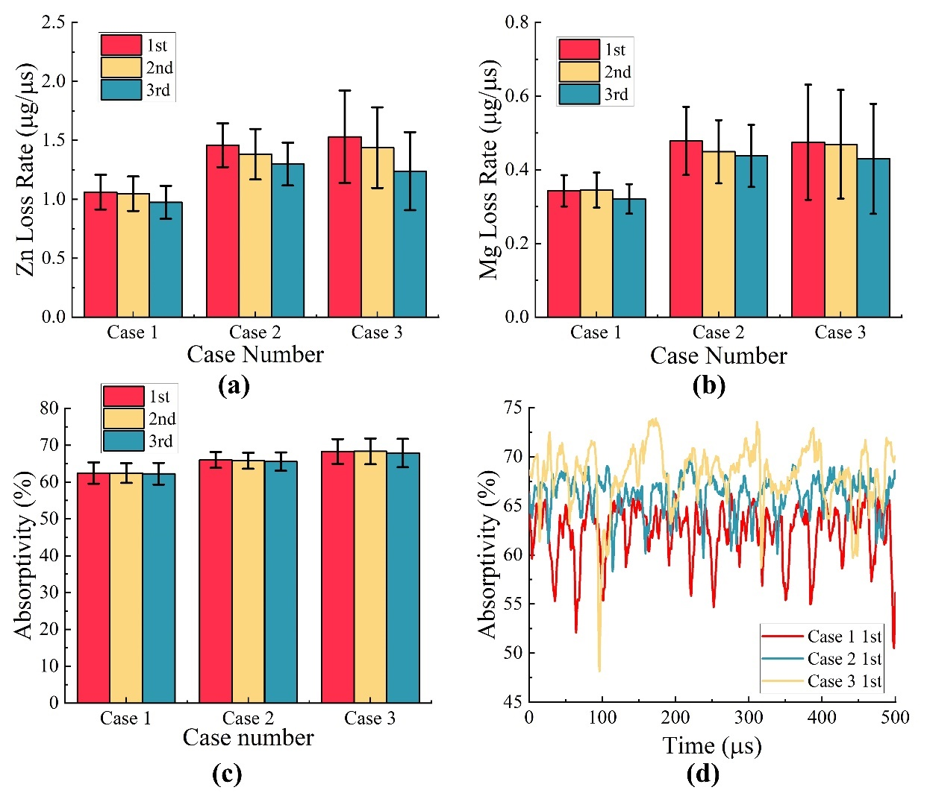
Figure S10: The average mass loss rate of (a) Zn and (b) Mg, and (c) laser absorptivity at different cases and remelting cycles. (d) The variation of laser absorptivity during the first track laser scanning.

- Figure 1 b-g and their captions should be reconfigured and revised because the texts and figures are not presented in chronological order which is not deemed to meet the journal standards.

Response:
Thanks for your suggestion. Figure 1 b-g are presented in chronological order in the manuscript. The texts in line 75-88 mainly discuss the EPMA and simulated Zn concentration results in Figure 1 b-e. The text in line 89-91 discusses the concentration distribution varies at different cross sections as indicated in Figure 1 f-g.

- The link between 2.1 and 2.2 is very disjointed. An explanation of the choice of the locations (sample extraction) and processing conditions should be added to the method or the main texts. It remains unclear how these samples are made and prepared for such tests. A clear schematic is needed to guide the readers through what you have done.

Response:
Thanks for your suggestion. The element concentration in the molten pool is nonuniform as discussed in Section 2.1. Therefore, we want to further analyze its influence on the mechanical property and conduct micropillar compression tests in the different regions in the melt and unmelt region. As shown in Figure 1b, the P0 is in the unmelt region, taken as benchmark. In the melt region, P1 is close to the edge of the track, P3 is in the bottom of the track, and P2 is between these two points. As shown in Figure 1b, P1 and P3 are in the low Zn concentration region, and P2 may also have a low Zn concentration. To exclude the influence of crystal orientation, P0-P4 are along to the [111] direction. In section 4.4, we add a specific description of how we prepare the pillar sample. The explanation about the choice and processing conditions in the manuscript as attached below.

In line 127-137
The locations of micropillar are precisely determined using Electron Backscatter Diffraction (EBSD) as shown in Figure 2b and EPMA results. According to the distribution pattern of Zn concentration, P0 is located in the substrate (unmelt region) and serves as the reference point. P1 is situated at the edge of the melt region, P3 at the bottom of the melt region, and P2 between P1 and P2. The Zn concentrations in P1-P3 are 1.0-2.0% lower than that in the substrate (P0), as shown in Figure 1b. Moreover, the crystal orientations for compression points are aligned [111] to exclude the influence of the crystal orientation. Meanwhile, in the compression tests, by extracting P0-P3 (the pillars inside individual grains) with close kernel average misorientations (KAM) (Figure 2c), the influences of residual stress and initial dislocation hardening on the stress-strain responses can be excluded.

In line 350 -355
In the micro-pillar compression tests, a focused ion beam (FIB) at 30 kV in a FEI-600i dual-beam FIB/SEM system is applied to mill a circle ring with an out diameter of $∼20 μm$, an inner diameter of $∼5 μm$, and a depth of $∼0.4 μm$ in the first step, and then a micro-pillars of roughly $1.0 μm$ in diameter and $2.0 μm$ in height are extracted in the inner circle [57].

- ‘..stress-strain responses at different material points…’ What is the meaning of different material points?

Response:
Thank you for your suggestion. Material points is a terminology in Crystal Plasticity Finite Element (CPFE) modeling. It refers to specific locations within the finite element mesh where the material’s properties and behavior are evaluated. In this manuscript, we analyze the stress-strain responses at different material points. We have added an explanation about it in the manuscript as attached below.

In line 145-148
Furthermore, we use the constitutive model under crystal plasticity (CP) framework to quantify the effect of concentration distributions on stress-strain responses at different material points (locations within the finite element mesh), in which the solid-solution strengthening effect is incorporated.

- Section 2.3: What’s the difference between the composition of the extracted samples and the substrates? I think the authors should provide evidence to support their claims.

Response:
Thank you for your suggestion. The analysis of the concentration evolution mechanism is based on simulated results.

In the experiments, EPMA is conducted first to determine Zn concentration pattern. In the micro-pillar compression tests, the surface will be polished again and then prepare the micro-pillars. Therefore, the exact concentration in each point cannot be extracted. The difference of Zn concentration in position P1-P3 and P0 is listed in the manuscript. We are quantifying the difference of element concentrations and its influence on microstructure and mechanical properties in the future. We have revised our claim in the manuscript as attached below.

- Line 142 – 148: ‘…the keyhole fluctuates and expands, resulting in varying temperature distributions…’ Can you explain the underlying thermophysical phenomena and why this is the case?

Response:
Thanks for your suggestion. During the keyhole dynamic process, the forces on the keyhole surface is unstable and makes the keyhole surface fluctuates and expands to influence the heat convection in the molten pool. At the same time, the keyhole shape affects the laser reflects and absorption as shown in Figure R1 [35]. Therefore, the temperature on the keyhole surface varies at different locations and leads to non-uniform element evaporation rate on the keyhole surface. We have added a specific explanation about it in the manuscript as attached below.

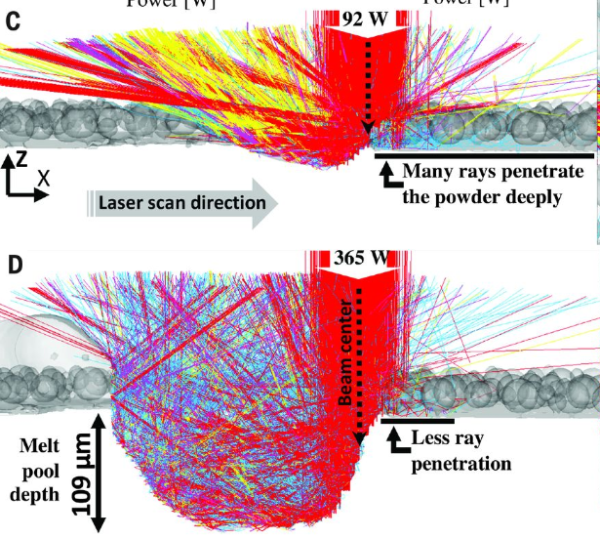
Figure R1. Laser-powder-molten pool interaction. (The color represents the energy density)

In line 168-173
During the L-PBF process, hydrodynamic and evaporation forces vary at different locations, causing fluctuations on the keyhole surface, which subsequently influence heat convection in the molten pool. Concurrently, the keyhole shape affects the Gaussian distributed laser reflection and absorption [35]. Therefore, Consequently, keyhole dynamics result in varying temperature distributions, leading to different local evaporation rates on the keyhole surface.

Reference
[35] Khairallah S A, Martin A A, Lee J R I, et al. Controlling interdependent meso-nanosecond dynamics and defect generation in metal 3D printing[J]. Science, 2020, 368(6491): 660-665.

- Line 206 – 212: The authors speculate that ‘this irregular element concentration variation at the bottom of the track during the solidification further impacts grain growth’. Can you be more specific about what impact will it make, e.g. promote or inhibit grain growth? In either case, you’d further explain to what extent such impact will lead to crack formation with support numeric values and establish a clear relationship between local grain growth, solidification shrinkage, and crack mechanisms.

Response:
Thanks for your suggestion. The concentration gradient significantly influences dendritic growth. A higher Zn concentration on the solidification front enhances constitutional supercooling and promotes dendritic growth. The varying speeds of dendritic growth facilitate the formation of interlocking solid networks, increasing the risk of cracking. We should admit that the influence of element concentration on dendrite/grain growth and cracking formation cannot be quantified in this simulation model. We are currently developing a microstructure evolution simulation model that incorporates element concentration to quantitatively analyze this complex issue. We have added a specific explanation about it in the manuscript as attached below.

In line 235-238
According to thermodynamics, the local element concentration of alloy largely determines Gibbs free energy and impacts the dendrite growth rate [2]. A higher Zn concentration on the solidification front can enhance constitutional supercooling and promote dendritic growth [41].

In line 241-244
This ever-changing dendrite growth rate could facilitate the formation of interlocking solid networks [9, 42], which increases the potential of cracking. A study on microstructure evolution considering concentration during L-PBF is essential to quantify the potential for crack formation in the future.

Conclusions:
- It remains inconclusive that the keyhole pores exacerbate elemental segregation unless the authors can provide EPMA maps for both cases.

Response:
Thanks for your suggestion. The distribution of keyhole pores is sporadic, making it challenging to obtain a cross-section containing a pore in experiments. Moreover, both keyhole pores and instant bubbles can impede liquid flow, further exacerbating element segregation. Transient bubbles can ascend to the surface of the molten pool and dissipate. Consequently, EPMA results are inconclusive in determining whether keyhole pores intensify element segregation. Further experimental validation is required to substantiate these findings, and we have accordingly moderated our conclusion as attached below.

In line 262-265
Furthermore, it is possible that the instant bubbles caused by keyhole collapse and keyhole pores exacerbates element segregation, hinder liquid convection, and play critical roles in cracking, aside from the high temperature gradient and cooling rate, which needs to be validated with more accuracy experiments.

Methods:
- Can you provide details of the effective diffusion coefficient of the element in a table? Does this account for temperature-dependent effects?

Response:
Thanks for your suggestion. In our model, we did not consider the diffusion effect. Element evaporation and liquid convection are the main factors. The diffusion effect is much smaller than the convection. We calculated the Peclet number in the molten pool

$$Pe=\frac{Ul_{c}}{D_{e}}∼{10}^{4}$$

Where the characteristic velocity $U$ and length $l_{c}$ in the molten pool are $2 m/s$ and $0.001 m$. The diffusion coefficient is temperature-dependent, the value of $D_{e}$ ranges ${10}^{-7}-{10}^{-8} m^{2}/s$between the melting and boiling temperature [53,55]. Since the Peclet number is very large, the solute diffusion effect is ignored in this model. We have revised the description of it in the manuscript as attached below.

In Line 309-315
According to the previous studies [37, 53, 54], the diffusion effect in the molten pool309
dynamics can be ignored compared to the convection effect. The temperature-dependent diffusion coefficient $D_{e}$ of element in alloy is about ${10}^{-7}-{10}^{-8} m^{2}/s$ from melting to boiling temperature [53, 55]. In L-PBF process, the characteristic velocity $U$ and length $l_{c}$ are 2 m/s and 1 mm, so the Peclet number is $Pe=\frac{Ul_{c}}{D_{e}}∼{10}^{4}≫1$, meaning that the convection is much stronger than diffusion. Thus, the simplified solute transport equation without diffusion is implemented in the current study

- Can you provide a reference model that is being used in equation 4? How did you convert your results into mass loss of individual elements?

Response:
Thanks for your suggestion. Equation is based on the mass conservation equation and we have provide references in the manuscript as attached below.

In line 305-309
$S_{v}$ is the element concentration loss rate due to the element evaporation [53,45], which is given as
$$S_{v}=-\frac{C{\dot{m}}_{m}-{\dot{m}}_{c,i}}{{\dot{m}}_{m}-{\dot{m}}_{evp}}$$
where ${\dot{m}}_{m}$and ${\dot{m}}_{c,i}$are the material melting rate and solute evaporating rate of $i$th element, respectively, and they are calculated with our evaporation model [45] (described in Supplementary Methods).

Reference
[53] Klassen A, Forster V E, Juechter V, et al. Numerical simulation of multi-component evaporation during selective electron beam melting of TiAl[J]. Journal of Materials Processing Technology, 2017, 247: 280-288.
[45] Wang L, Zhang Y, Yan W. Evaporation model for keyhole dynamics during additive manufacturing of metal[J]. Physical Review Applied, 2020, 14(6): 064039.

- The current manuscript did not demonstrate your model would work on a powder case. Therefore, the authors cannot claim this work is for AM or LPBF.

Response:
Thanks for your suggestion. During the L-PBF process, the raw materials are melted and solidified and a dynamic molten pool forms during the laser scanning. We use laser scanning on bare plate can make it easier for us to obtain accurate experimental and simulation results by excluding the influence of the powder particles on the molten pool flow and laser absorption. Additionally, to validate our model, we conduct experiments and simulation for L-PBF fabricated high entropy alloy as attached in the supporting information. The Mn concentration in both experiments and simulations matches.

- There are not sufficient details about why the HEA sample is mentioned in this manuscript.

Response:
Thanks for your suggestion. HEA is a demonstration that our model is applicable for other alloys.

